CIRCUIT ANALYSIS LAB_4
Name: Muhammad Uzair
Reg No: 2025-CE-112
Date: 28thMarch,2026

Experiment # 1:
Measure the current across R1, R2, R3 and Voltage between node 2 and 7.
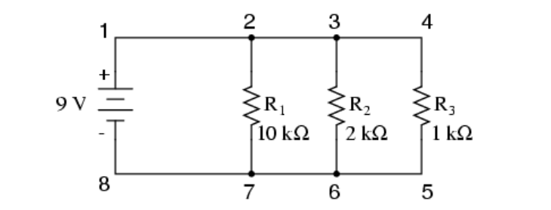

TABLE FOR READINGS:
Practical Values:
R₁ Current | R₂ Current | R₃ Current | Voltage between node 2 & 7
0.9mA | 4.5mA | 9mA | 9V

Theoretical Values:
R₁ Current | R₂ Current | R₃ Current | Voltage between node 2 & 7
0.9mA | 4.5mA | 9mA | 9V

Experiment # 2:
Measure the current across R1, R2, R3 and Voltage between node a and e.
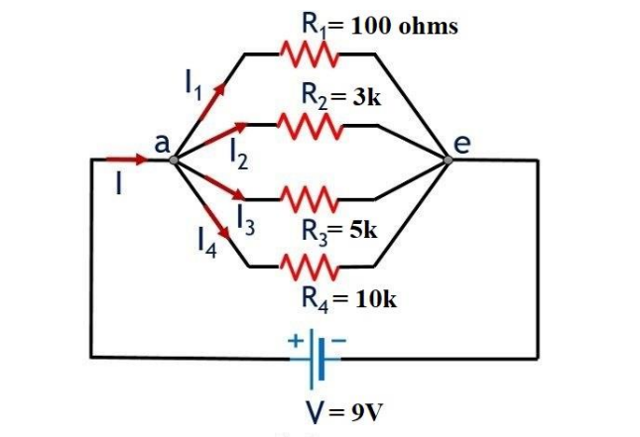
TABLE FOR READINGS:
Practical Values:
R₁ Current | R₂ Current | R₃ Current | R₄ Current | Voltage between node a and e
90mA | 3mA | 1.8mA | 0.9mA | 9V

Theoretical Values:
R₁ Current | R₂ Current | R₃ Current | R₄ Current | Voltage between node a and e
90mA | 3mA | 1.8mA | 0.9mA | 9V
POST LAB QUESTIONS & ANSWERS:

1. Why is the value of voltage across each resistor in parallel circuit same?
In a parallel circuit, all resistors are connected across the same two nodes. Therefore, the potential difference (voltage) between these nodes is the same for every resistor, regardless of their resistance.

2. When parallel resistors are of three different values, which has the greatest power loss?
The resistor with the smallest resistance has the greatest power loss because in parallel circuits, current through a resistor is inversely proportional to its resistance. Power loss is P=I2RP = I^2 RP=I2R, and the higher current through the smaller resistor results in more power dissipated.

3. How the current across any branch of a parallel circuit varies?
The current in each branch of a parallel circuit depends on the resistance of that branch. Lower resistance allows more current, while higher resistance allows less current. The sum of currents in all branches equals the total current supplied by the source.

4. What happens to total resistance in a circuit with parallel resistors if one of them opens (i.e. removed)?
If one resistor is removed, the total resistance increases because there are now fewer paths for current to flow. Total resistance in parallel is always less than the smallest individual resistor, so removing a branch increases the total resistance.

